Grap hic Design Theory

**[](https://gamma.app/?utm_source=made-with-gamma)**

Graphic design is an important field that combines creativity and visual communication. It involves using elements like color, shape, and text to create designs that share ideas clearly and attractively. This assignment explains the basic concepts of graphic design, including its definition, key elements, and principles. It also covers important topics such as color theory, typography, and layout composition. These concepts are explained with examples to help understand how graphic design works in real-life projects.

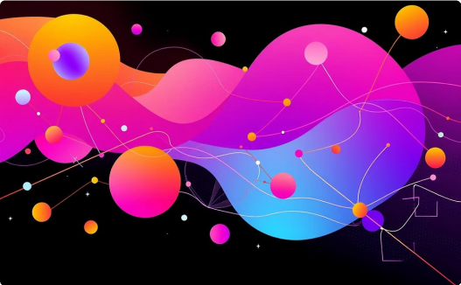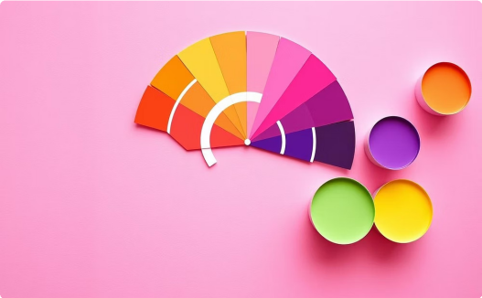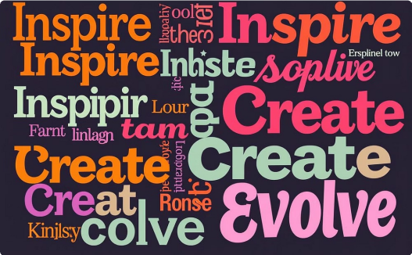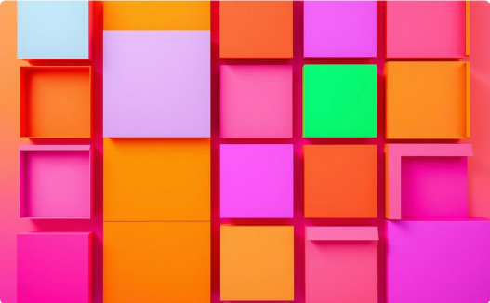

## Design Fundamentals

Learn the basic meanings, important parts, and main rules of design that help create clear and effective visual messages.

## Color Theory

Understand how colors affect feelings and how to use them in design to catch attention and create emotions.

## Typography

Learn how fonts and text styles (typefaces) are used in design. Understand how the shape and size of letters can change the look and feel of your design.

## Layout & Composition

Learn how to arrange text, images, and colors in a proper way to make your design neat, attractive, and easy to understand.

[](https://gamma.app/?utm_source=made-with-gamma)

# Defining Graphic Design and Its Impact

Graphic design is not just about making things look beautiful. It is the art of planning and sharing ideas through pictures and words. It mixes creativity and technology to send messages to people. In today¾s digital world, where we see a lot of information everywhere, graphic design helps make complex ideas easy to understand. It changes how we see brands, use websites or apps, and learn new things. That¾s why graphic design is very important for communication in all types of work.

Graphic design is very important in the digital age. Today, people use websites, apps, and social media a lot. So, designs must look good and be easy to use. A good website, a nice-looking social media post, or an app that is easy to understand can improve the user¾s experience and help a business grow. Graphic design helps solve problems using pictures and layout. It makes information clear, easy to read, and pleasant to look at.

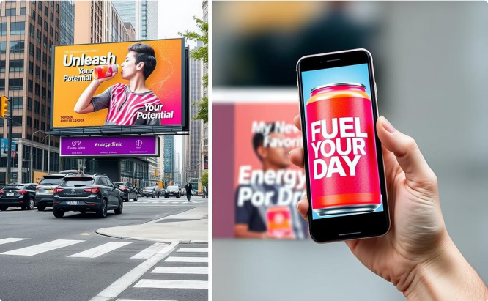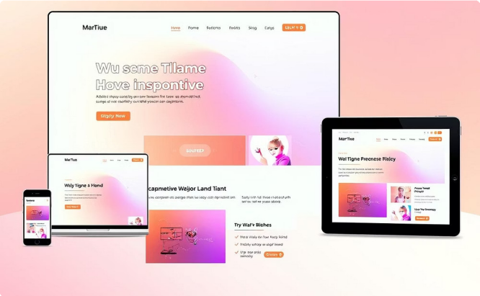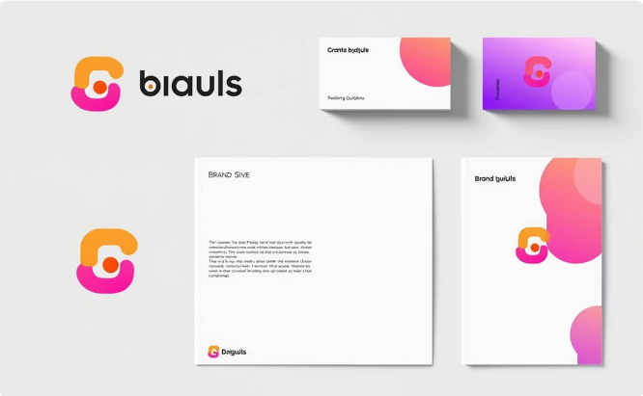

## Advertising

Graphic design is a very important part of advertising. It helps create eye- catching messages for things like newspapers, websites, TV, and social media. Designers make logos, brochures, billboards, banner ads, and social media posts that attract people and share the brand's message clearly. To do this well, designers need to understand what people like and how they think. This helps them make designs that catch attention, interest people, and help increase sales.

## Web Design

[](https://gamma.app/?utm_source=made-with-gamma)In web design, graphic design focuses on how the website looks and how users interact with it (this is called the user interface or UI). This includes creating layouts that work well on all screen sizes (called responsive layouts), making sure navigation is simple and easy to use, adding attractive visual elements, and keeping the same branding style on all devices. The goal is to give users a smooth and pleasant experience (user experience or UX), so they enjoy using the website and can do what they came to do 4 like reading information or shopping online.

## Branding & Identity

This area focuses on creating a special and unique visual look for companies, products, or services. It includes designing logos, business stationery, brand rules (called brand guidelines), and other visual things that show the brand's personality and values.

Graphic designers make sure everything looks the same wherever the brand appears. This helps people recognize the brand, trust it, and stay loyal to it.

# The Seven Key Elements of Design

The elements of design are the basic parts artists and designers use to create any visual work. Learning these core elements helps you communicate clearly and thoughtfully, forming the base for all creative projects.

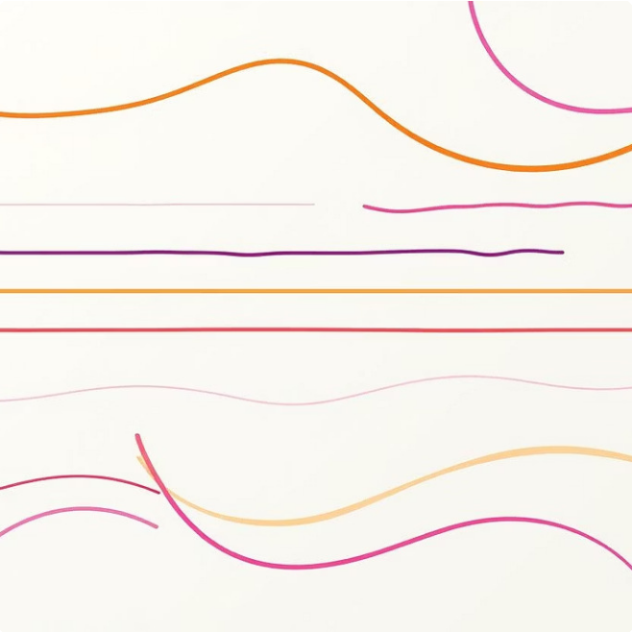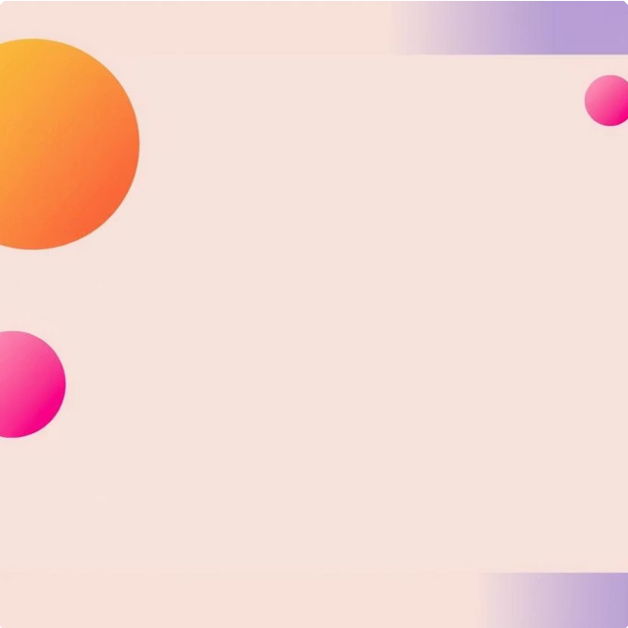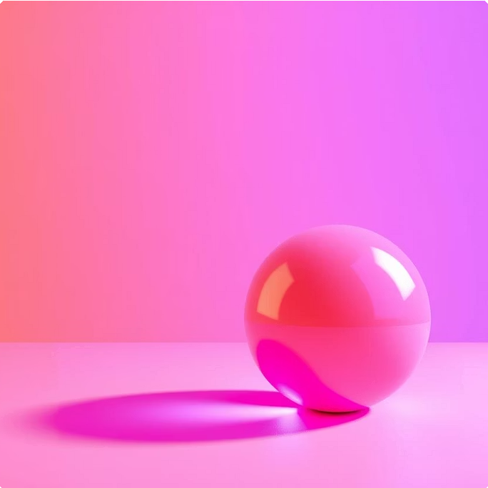

### Line

A line is a mark that shows direction, shape, and structure. Lines can be used to outline shapes, show movement, or separate different areas, like dividing sections on a webpage.

### Shape

A shape is a flat, closed area made by lines or color. Shapes help make a design look interesting and help organize content, such as highlighting important text.

### Form

Form means a 3D object that has height, width, and depth. In design, we show form using shadows and perspective to make things look real, even on a flat screen.

 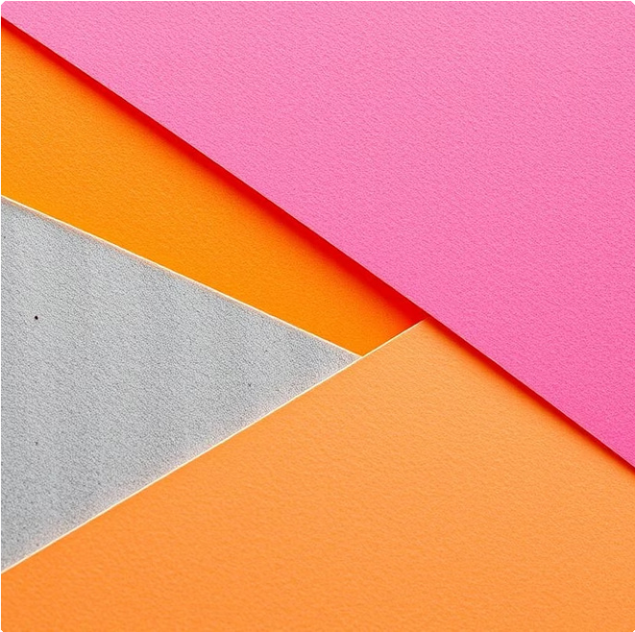 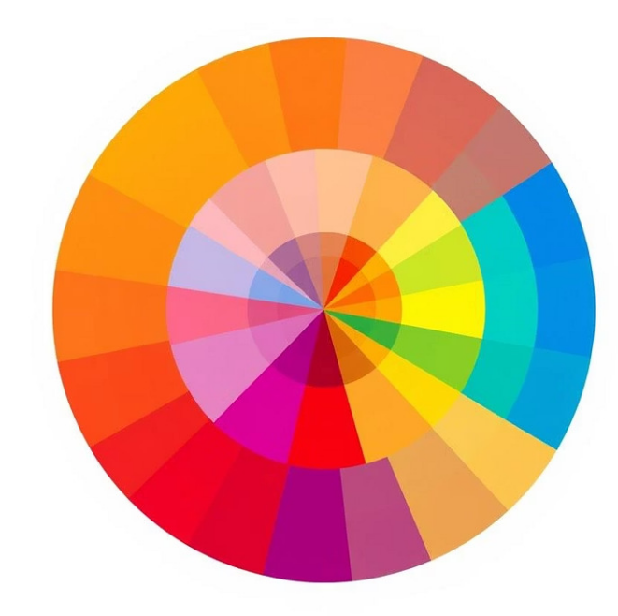

### Space

Space is the empty area around, between, or inside design elements. Using space properly helps some parts stand out and makes the content easier to read.

### Texture

Texture is how an object¾s surface looks or feels. It adds small details and interest to a design and can create different moods, like a vintage or old- fashioned feel.

### Color

Color is how we see light reflecting off an object. It can create different emotions, guide where we look, and set the mood. It also helps important items stand out quickly.



### Value

[](https://gamma.app/?utm_source=made-with-gamma)Value shows how light or dark a color is. It ranges from white to black and helps create contrast, show form, and add depth and feeling to a design.

# Principles of Design: Crafting Visually Compelling Work

The elements of design are like the building blocks, but the principles of design are the rules and instructions that tell us how to use those blocks. These rules help us arrange and combine the elements to make a clear, complete, and powerful design. They make sure the design not only looks good but also shares the message properly and strongly.

### Balance

1

Balance means how visual weight is spread across a design. It can be symmetrical, where things on both sides of the center are the same, which feels stable and formal. Or it can be asymmetrical, where the sides are different but still feel balanced 4 giving a modern and dynamic look.

### Contrast

2

Contrast means showing a difference between two or more things in the design. This can be done by changing size, color, texture, shape, or font style. High contrast catches the viewer¾s attention and makes the design interesting, while low contrast makes things feel soft and connected.

### Emphasis

3

Emphasis means making one part of the design stand out 4 the part you want people to see first. You can do this using contrast, size, color, or keeping it separate from other things. This helps the viewer notice the most important information right away.

### Movement

4

Movement is how the viewer¾s eyes move across the design. Lines, shapes, colors, and how things are placed can guide this movement. Good movement helps the viewer look at the design in a clear and interesting order.

### Pattern

5

Pattern is when you repeat design elements, either in the same way or with a little change. Patterns make the design more interesting, and they can also bring a feeling of rhythm and connection throughout the design.

### Rhythm

6

Rhythm comes from repeating elements that are not exactly the same but are related. It¾s like music 4 the eye moves through the design in a smooth or predictable way. This adds a sense of flow, energy, and harmony.

### Unity

7

[](https://gamma.app/?utm_source=made-with-gamma)Unity (also called harmony) means that everything in the design works well together. A unified design feels complete and organized. Nothing feels out of place. Unity happens when all the other design principles are used correctly.

# The Psychology of Color in Design



Color is one of the most powerful tools that a designer can use. It can change how people see things, make them feel certain emotions, and even guide how they behave 4 all without saying a single word. Our brains are naturally built to connect certain colors with certain feelings, ideas, or cultural meanings. This is called **color psychology**. When used in the right way, color can make text easier to read, help build a brand¾s identity, and make people feel the emotions the designer wants them to feel.

For example, a food ad might use warm and friendly colors to make people feel hungry and interested, while a tech company might use cool and smart-looking colors to show they are modern and trustworthy. Knowing how people react to colors is very important for good visual communication.

### Emotional Effects of Key Colors:

##### Red:

Red is often connected to passion, energy, excitement, danger, and urgency. It can make your heart beat faster and give a feeling that something needs attention right now. That¾s why it is often used for buttons like

<Buy Now= or for warning signs.

##### Blue:

Blue makes people feel calm, safe, smart, and professional. It is often used by banks, tech companies, and hospitals because it shows trust and security.

##### Yellow:

Yellow stands for happiness, hope, warmth, and creativity. But using too much yellow can feel too strong or like a warning. It is good for catching attention and showing something positive.

##### Green:

Green is a symbol of nature, health, freshness, peace, and money. It feels relaxing and is often used for eco- friendly brands, health products, or when showing something new.

##### Black:

Black shows elegance, power, style, and mystery. Sometimes it also means seriousness or sadness. It is often used by luxury brands or to make strong contrast in designs.

##### White:

White means purity, simplicity, cleanliness, and a modern feel. It gives space in a design and helps other colors stand out. It is commonly used in backgrounds to keep things easy to read.

# Color Theory Basics: Understanding the Spectrum

Color theory provides a framework for understanding how colors work together, how they mix, and how they impact a design. It's a critical discipline for designers, artists, and anyone working with visual media.



Primary, Secondary, and Tertiary Colors

**Primary colors** (Red, Yellow, Blue) are the foundational colors from which all other colors can be mixed. They cannot be created by mixing other colors.

**Secondary colors** (Orange, Green, Purple) are formed by mixing two primary colors.

**Tertiary colors** are created by

mixing a primary and a secondary color (e.g., Red-Orange, Blue- Green).



Hue, Saturation, and Brightness

**Hue** refers to the pure spectrum of colors (e.g., red, blue, yellow). It's the technical term for what we commonly call "color." **Saturation** describes the intensity or purity of a color4how vibrant or dull it appears. A highly saturated color is vivid, while a desaturated color leans towards gray. **Brightness** (or Value/Lightness) is the relative lightness or darkness of a color, ranging from white to black.



Color Schemes

**Monochromatic:** Uses different shades, tints, and tones of a single hue, creating a harmonious and sophisticated look.

**Analogous:** Employs colors that are adjacent to each other on the color wheel, offering a calm and comfortable feel, often found in nature.

**Complementary:** Uses two colors directly opposite each other on the color wheel, creating high contrast and visual vibrancy (e.g., red and green). Best used in small doses for emphasis.

**Triadic:** Consists of three colors equally spaced on the color wheel, forming a triangle. This scheme offers strong visual contrast while maintaining balance and richness.

# Color Models and Systems: RGB, CMYK, Pantone, and HEX

Understanding color models is crucial for designers, as different models are used for different media (digital vs. print) and impact how colors are reproduced.

### RGB Color Model

RGB stands for Red, Green, and Blue. It is an **additive color model**, meaning colors are created by adding varying intensities of red, green, and blue light. When all three colors are combined at their full intensity, they produce white light. When all are absent, the result is black. RGB is primarily used for **digital displays** such as computer monitors, televisions, cameras, and mobile devices. This is because these devices emit light. If you are designing for websites, apps, or any screen-based content, you will work in RGB.

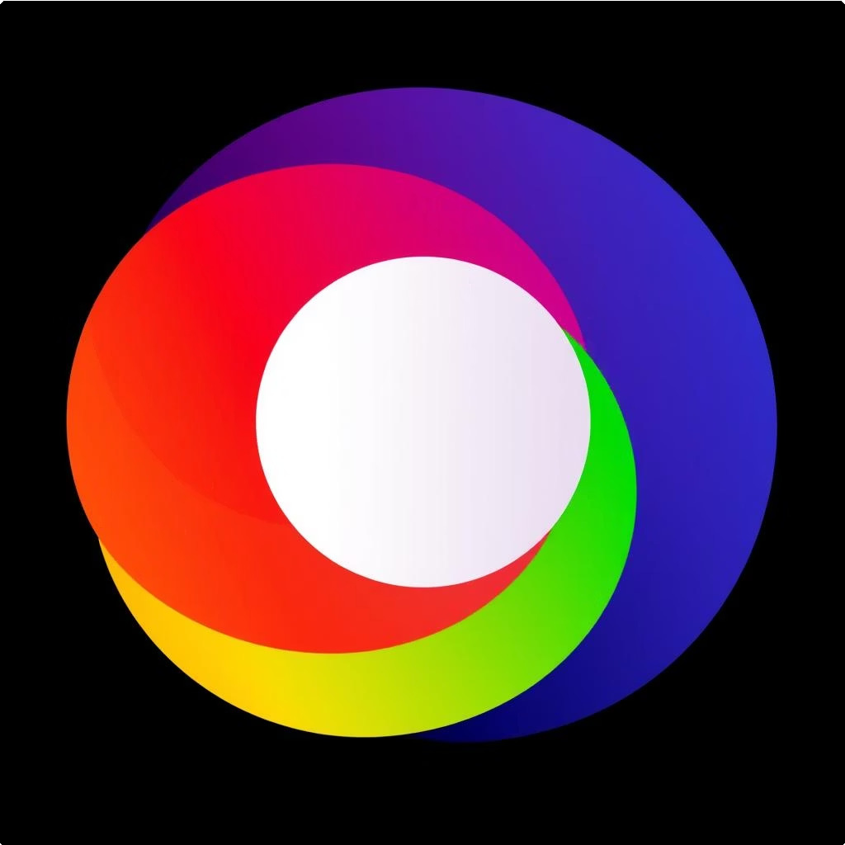

### Pantone Colors and HEX Colors



CMYK Color Model

CMYK stands for Cyan, Magenta, Yellow, and Key (Black). It is a **subtractive color model**, meaning colors are created by subtracting light from white. When cyan, magenta, and yellow inks are combined, they theoretically absorb all light and produce black (though in practice, a true black is achieved by adding black ink, hence the "K"). CMYK is primarily used for **print media** such as brochures, posters, magazines, and business cards. Printers use these four inks to produce a wide range of colors on paper. The reason CMYK is used for print while RGB is for digital is fundamental: digital screens emit light, while printed materials absorb light.

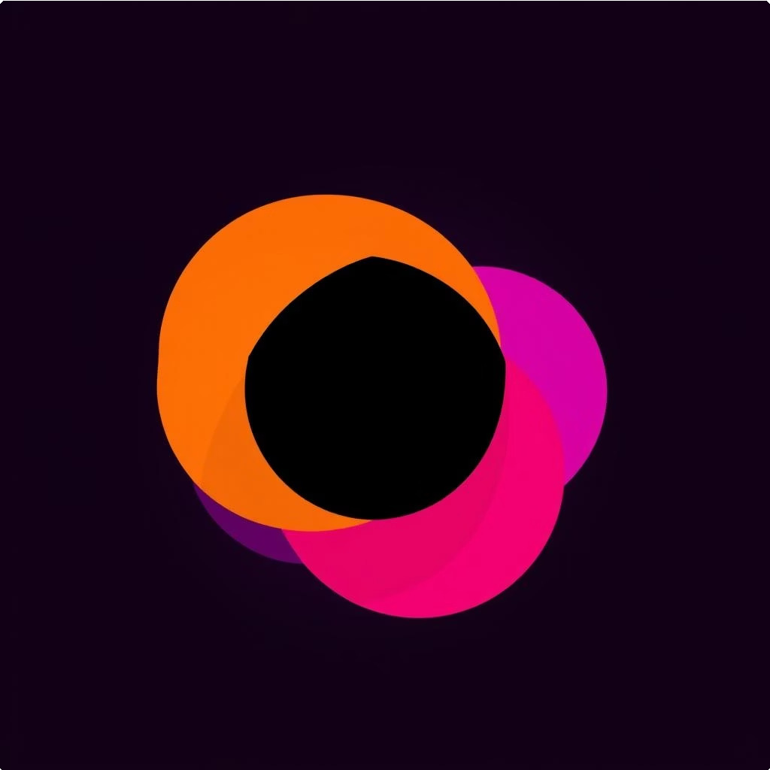

**Pantone Colors:** Also known as the Pantone Matching System (PMS), Pantone colors are a proprietary standardized color reproduction system. Each Pantone color is a specific, pre-mixed ink, identified by a unique number. This system ensures color consistency across different printing processes and materials, which is crucial for brand identity where precise color matching is essential (e.g., a specific brand's logo color). Pantone colors are widely used in commercial printing and manufacturing.

**HEX Colors:** Hexadecimal colors are a way of representing colors in web design and digital applications. A HEX code is a six-digit alphanumeric code (#RRGGBB) that specifies the intensity of Red, Green, and Blue light. For example, #FF0000 is pure red (full red, no green, no blue), and #000000 is black. HEX codes are a shorthand for RGB values and are fundamental for defining colors in HTML, CSS, and other digital design tools.

[](https://gamma.app/?utm_source=made-with-gamma)

# Typography Basics: Anatomy and Application of Typefaces

Typography is the art and technique of arranging type to make written language legible, readable, and appealing when displayed. It involves selecting typefaces, point sizes, line lengths, leading (line spacing), and kerning (adjusting space between letters).

|  |  |
| --- | --- |
| Typeface | A typeface (or font family) is the collective name for a group of fonts that share common design characteristics (e.g., Arial, Times New Roman). |
| Font | A font refers to a specific style, weight, and size within a typeface (e.g., Arial Bold 12pt). |
| Serif | Small decorative strokes or feet at the ends of character strokes (e.g., Times New Roman). |
| Sans-serif | Typefaces without serifs, characterized by clean lines (e.g., Arial, Helvetica). |
| Kerning | The adjustment of space between individual characters to improve legibility and appearance. |
| Leading | The vertical space between lines of text, also known as line spacing. |
| Tracking | The uniform adjustment of space across a range of characters or words, affecting density. |
| Baseline | The invisible line upon which the text sits. |

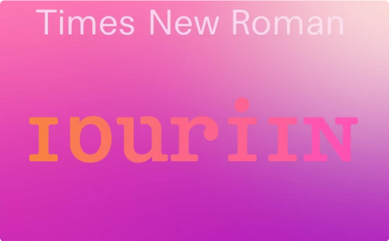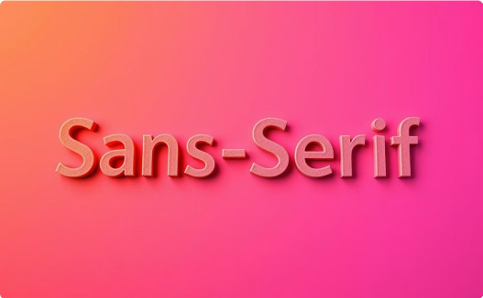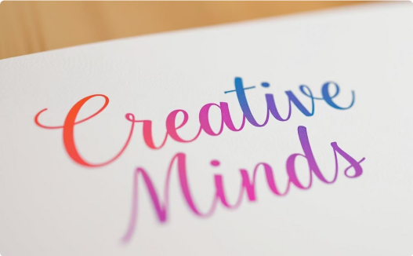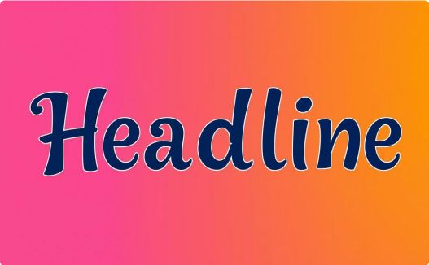

### Serif Typefaces

Known for their classic, traditional, and authoritative feel, serifs are excellent for long-form body text in print (books, newspapers) due to their readability. They guide the eye along the line of text.

### Sans-serif Typefaces

Modern, clean, and minimalist, sans-serifs are highly readable on screens (websites, apps) and for headings, signage, and corporate branding. Their simplicity makes them versatile.

### Script Typefaces

Mimicking handwriting, script typefaces convey elegance, formality, or a personal touch. Best used sparingly for invitations, logos, or headlines where a decorative flair is desired.

### Decorative Typefaces

[](https://gamma.app/?utm_source=made-with-gamma)Highly artistic and often unique, decorative (or display) typefaces are designed for specific purposes and strong visual impact. Ideal for headlines, posters, or very short text that needs to stand out dramatically.

# The Profound Influence of Typography in Design

Typography is not only about choosing a font; it is a powerful tool that strongly affects how easy the text is to read, how information is arranged, and how the design looks overall. It is like a silent storyteller that shows feeling, emotion, and professionalism even before a word is fully read. Good typography makes sure that the message is not just understood but also felt, helping guide the reader smoothly through the content.

For readability, using the right typeface, size, spacing between lines (called leading), and space between letters (called kerning) makes the text easy to read. It helps avoid eye strain and keeps the reader interested. On the other hand, poor font choices can cause confusion and make people stop reading.

For hierarchy, typography sets a clear order of information. It separates headings, subheadings, body text, and captions. Changing font sizes, boldness (like bold or light), and colors helps lead the eye to the most important information first, then to the rest. This organized way of presenting text avoids confusion and makes the message easier to understand.

[](https://gamma.app/?utm_source=made-with-gamma)From the design (aesthetic) point of view, typography adds a lot to the mood and personality of the design. A simple **sans- serif** font can give a modern feeling, while a fancy **serif** font can give a traditional look. This visual feeling is important for brand identity. For example, Google¾s simple and clean sans-serif logo shows that it is easy to use and modern. The New York Times uses a traditional serif font to show trust and history. Choosing the right typography can help a brand stand out, be remembered, and connect with the audience 4 just like a logo or brand colors.

Layout and Composition: Structuring Visual Harmony

Layout and composition are about the arrangement of visual elements on a page or screen to create an organized, engaging, and effective design. They dictate how the viewer¾s eye moves, how information is perceived, and ultimately, how clear the communication becomes.

#### Grid Systems: The Unseen Framework

A **grid system** is a framework made up of intersecting lines (vertical and horizontal) that divide a page into sections. Its purpose in graphic design is to provide structure, consistency, and alignment for content. Grids help designers organize elements, maintain visual hierarchy, and create a sense of order, making designs more professional and easier to navigate. They aren't always visible in the final product but serve as the underlying blueprint.

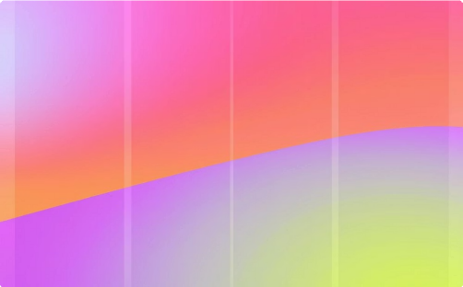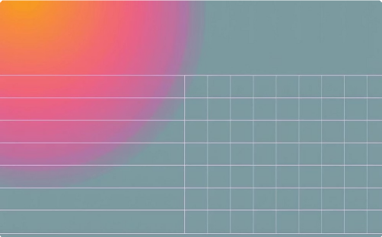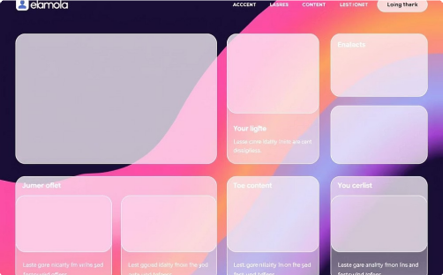

Column Grid

Divides the page into vertical columns, excellent for text-heavy content like magazines or newspapers. It allows for flexible content placement within defined boundaries, making it easy to create multiple text flows or integrate images.

Modular Grid

Extends the column grid by adding horizontal rows, creating a system of modules (rectangles). Ideal for complex layouts with diverse content types (text, images, ads), providing precise control over element positioning.

Hierarchical Grid

Emphasizes certain areas over others, often used for designs with a strong focal point or unconventional layouts like posters or single-page websites. It¾s less rigid, designed to guide the eye through varied content blocks.

#### Alignment and Balance: Creating Structure

**Alignment** is the arrangement of elements in a straight line or in parallel to other elements. It is crucial for creating order, neatness, and visual connection between disparate design components. When elements are aligned, they appear more organized and professional, enhancing readability and overall aesthetic appeal. Poor alignment leads to a messy, unprofessional, and often confusing design.

**Balance** refers to the distribution of visual weight within a composition. It ensures that no single part of the design feels too heavy or too light, creating stability and harmony.

Symmetrical Balance

Achieved when elements on one side of a central axis mirror those on the other side. This creates a sense of formality, stability, and traditional beauty. It's often seen in official documents, classical architecture, and traditional branding.



#### Visual Hierarchy: Guiding the Eye

Asymmetrical Balance

Achieved when dissimilar elements are arranged to create a sense of equilibrium. For example, a large element on one side might be balanced by several smaller elements on the other. This creates a more dynamic, modern, and engaging design, often feeling more energetic and spontaneous.



**Visual hierarchy** is the arrangement of elements in a design in order of importance. It helps guide the viewer¾s attention through the content. It makes sure that the most important information is seen first, followed by the supporting details, so the viewer¾s eye moves in a clear and natural way. If there is no clear hierarchy, the design can look messy and confusing.

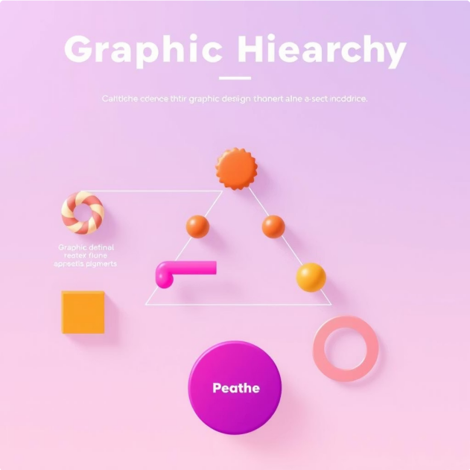Techniques to create visual hierarchy:

 **Size and Scale:** Larger elements naturally draw more attention. A headline is typically larger than body text to immediately signal its importance.

 **Color and Contrast:** Bright, saturated colors or strong contrasts can make elements stand out. A call-to-action button in a vibrant color against a muted background immediately grabs the eye.

 **Placement and Proximity:** Elements placed at the top or center of a layout, or isolated from other elements, often gain more prominence. Grouping related items together (proximity) also helps in organizing information and creating visual units.

[](https://gamma.app/?utm_source=made-with-gamma) **Typography (Weight, Style):** Using bold fonts, italicized text, or different typefaces can emphasize specific words or phrases, making them stand out from the rest of the content.